CHAPTER 19: MULTIPLE DOCUMENT INTERFACE

MDI (Multiple-Document Interface):

It's a design approach for applications that manage multiple documents in Microsoft Windows.

It allows users to work with several documents simultaneously within a single application window.

Think of it like having multiple tabs open in your web browser, but for different documents within the same program.

Key concepts:

* Parent window: The main application window that holds all the document windows.
* Child windows: The individual document windows that reside within the parent window.
* Client area: The part of the parent window where the child windows are displayed.

How MDI works:

Opening documents: Each document opens in its own child window within the parent window.

Arranging windows: Users can arrange child windows in various ways:

* Tile them horizontally or vertically to view multiple documents side-by-side.
* Cascade them to overlap like a stack of cards.
* Arrange them manually by dragging and resizing.

Switching between windows: Users can switch between documents by clicking on the desired child window, or using keyboard shortcuts.

Managing windows: The application provides features to manage child windows, such as:

* Arranging them (as mentioned above).
* Minimizing, maximizing, or closing them.

Benefits of MDI:

Efficient multitasking: Enables working on multiple documents simultaneously without cluttering the desktop with separate application windows.

Easy comparison: Allows side-by-side comparison of documents for easier referencing and editing.

Organization: Helps keep related documents grouped together within a single application.

Examples of MDI applications:

* Older versions of Microsoft Office applications (Word, Excel, PowerPoint)
* Adobe Photoshop
* Many text editors and code editors

Modern trends:

While MDI was common in older Windows applications, newer applications often use alternative approaches like:

* Tabbed interfaces (similar to web browsers)
* Single-document interfaces (SDI) where each document opens in its own separate window

These approaches offer different user experiences and trade-offs in terms of window management and organization.

MDI in Historical Context:

Early Complexity: While MDI was introduced in Windows 2.0, its implementation was challenging for developers due to intricate programming requirements.

Greater Support: Windows 3.0 and subsequent versions significantly streamlined MDI development by providing built-in support and enhancements.

Key Elements of MDI Applications:

Main Application Window:

Similar to standard application windows, featuring a title bar, menu, sizing border, system menu icon, minimize/maximize/close buttons.

Unique client area, often called the "workspace," designed specifically to house child windows instead of direct program output.

Child Windows (Document Windows):

Resemble small application windows within the main window's workspace.

Possess title bars, sizing borders, system menu icons, minimize/maximize/close buttons, and potentially scroll bars.

Notably lack their own menus, relying on the main application window's menu for actions.

Active Document:

Only one child window can be active at a time, indicated by a highlighted title bar.

Active window appears in front of other child windows, ensuring focus.

Document Containment:

Child windows are confined to the workspace area within the main application window, preventing them from extending beyond its boundaries.

Essential Programming Considerations:

* Window Management: MDI support involves specific functions and data structures for managing the relationship between the main application window and its child windows.
* Message Handling: MDI applications must process window messages differently to coordinate interactions between the main window and child windows.
* User Experience: Programmers must carefully design the MDI interface to ensure intuitive navigation, window management, and document interaction for users.

BEYOND INITIAL IMPRESSIONS:

While Multiple-Document Interface (MDI) might seem straightforward at first glance, it quickly reveals a nuanced set of complexities that demand careful attention from developers. Let's delve deeper into the key elements and considerations involved in crafting effective MDI applications.

Unveiling the Nuances:

Minimized Windows:

* These windows gracefully tuck themselves away as compact title bars with icons, residing at the bottom of the workspace.
* To aid visual clarity, they typically adopt distinct icons from the main application window, ensuring easy differentiation.



Maximized Windows:

* In this state, they seamlessly blend their title bars with the main window's, effectively appending document filenames for a cohesive display.
* System menu icons and close buttons relocate to the main window's menu bar, maintaining a unified interface while preserving access to essential controls.

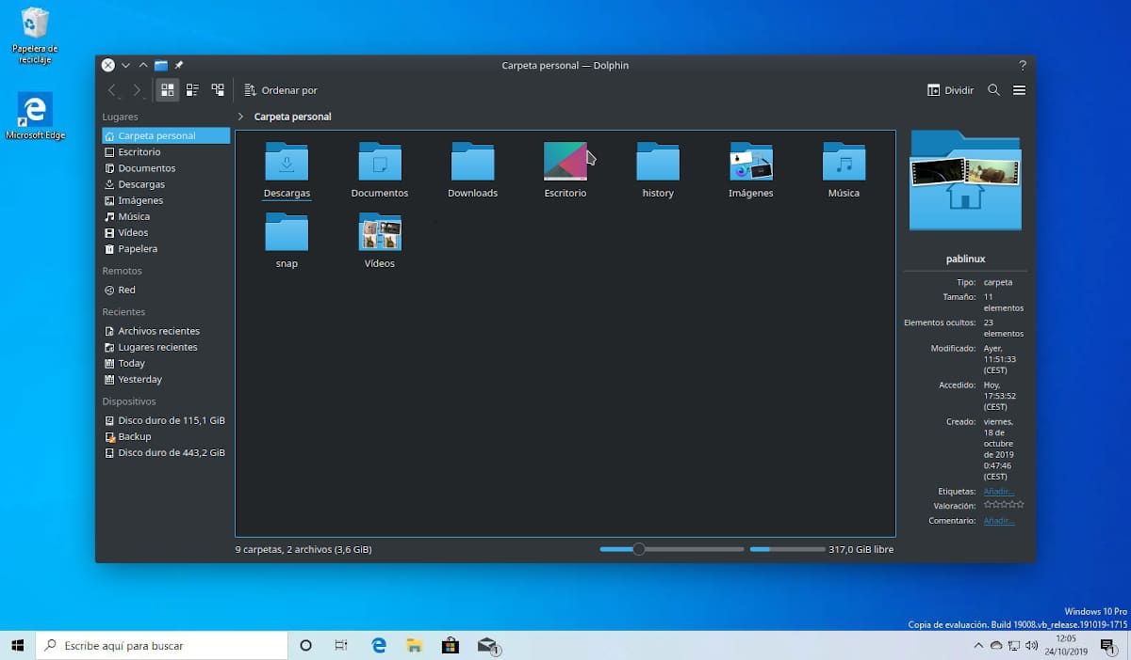

Keyboard Shortcuts for Efficiency:

* Ctrl+F4 offers a swift way to close document windows, while Alt+F4 retains its traditional role of closing the main application window.
* Ctrl+F6 enables effortless switching between child windows, promoting fluid navigation.
* Alt+Spacebar remains dedicated to invoking the main window's system menu, and Alt+- (minus) unlocks the active child window's system menu for granular control.

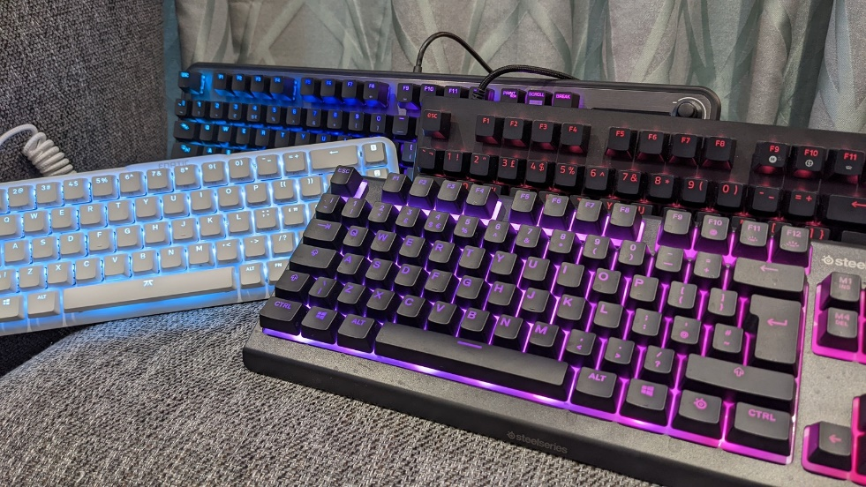

Menu Navigation: A Unified Journey:

* Cursor keys gracefully guide users through MDI menus, initiating their journey at the application system menu, then gracefully transitioning to the active document system menu, before finally arriving at the first item on the main menu bar. This intuitive flow promotes a cohesive user experience.



Context-Aware Menus:

* Intelligent applications dynamically adapt their menus based on the active document's type, ensuring that only relevant actions are presented.
* This responsiveness extends to the absence of document windows, where menus gracefully streamline to showcase options for opening or creating new documents, minimizing clutter and guiding users towards primary tasks.

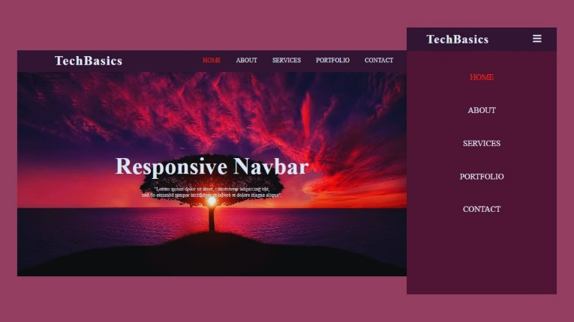

The Window Menu: A Command Center for Document Management:

* Nestled strategically within the top-level menu bar, typically preceding the Help menu, this dedicated menu empowers users to effortlessly arrange and access document windows.
* It offers convenient options for cascading windows in an overlapping fashion or tiling them for full visibility, catering to different organizational preferences.
* A comprehensive list of all open document windows resides within this menu, enabling users to swiftly select and activate desired documents with a single click.

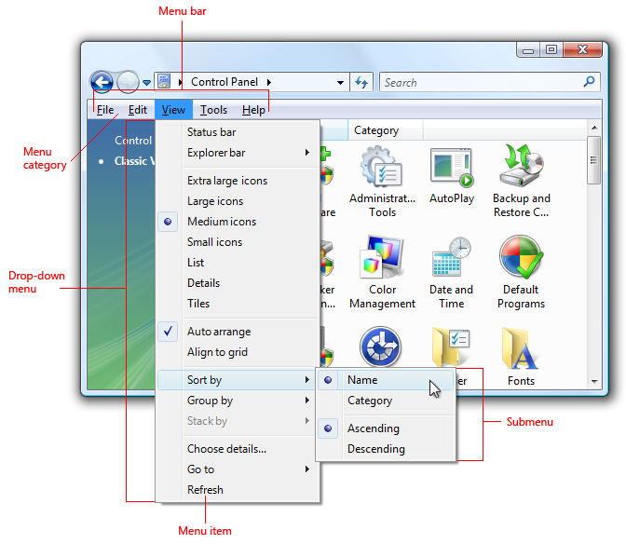

Windows 98: A Helping Hand:

* Windows 98 extended a valuable hand to developers by incorporating built-in support for these MDI features, significantly reducing the programming effort required for their implementation.
* While this support does introduce some overhead, it's a small price to pay compared to the manual implementation of such a comprehensive set of functionalities.

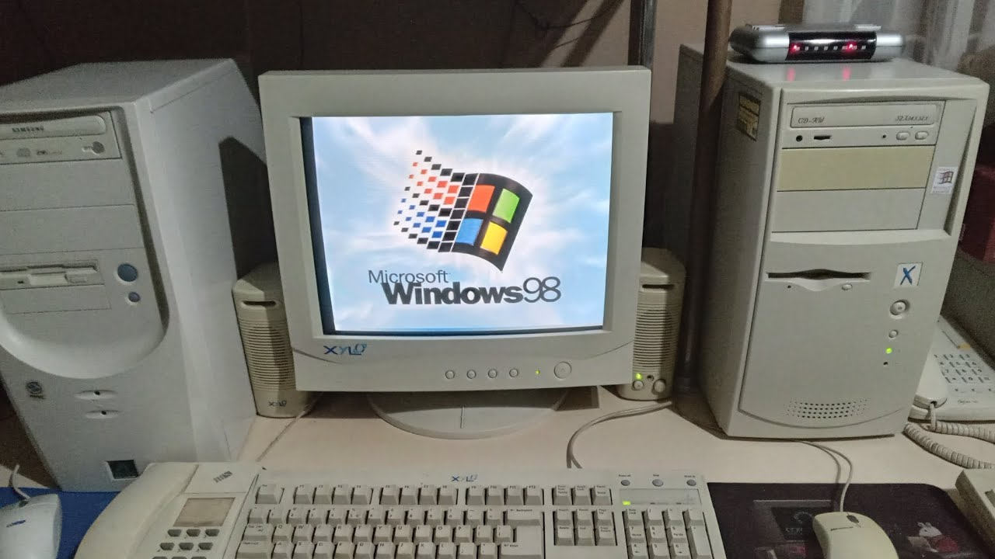

MDI: A FAMILY OF WINDOWS

To create a well-structured Multiple-Document Interface (MDI) application, it's crucial to understand the relationships between its various window types:

1. Frame Window:

The majestic patriarch of the MDI family, this window serves as the main application window.

It possesses the WS_OVERLAPPEDWINDOW style, granting it the familiar features of a standard Windows window, including a title bar, menu, sizing border, and system buttons.

2. Client Window:

This loyal servant, a child of the frame window, is crafted using the predefined MDICLIENT window class.

It's given life through a call to CreateWindow with the WS_CHILD style, and it dutifully covers the frame window's client area like a protective cloak.

The CLIENTCREATESTRUCT structure, passed as an argument to CreateWindow, provides additional guidance for its creation.

Its color, derived from the system color COLOR_APPWORKSPACE, often blends seamlessly with the frame window, creating a unified workspace for child windows.

3. Child Windows (Document Windows):

These diligent offspring, representing individual documents, reside within the client window's workspace.

To bring them into existence, an MDICREATESTRUCT structure is meticulously prepared and sent to the client window via a WM_MDICREATE message.

They lack their own menus, deferring to the frame window's menu for actions.

The MDI Hierarchy:

* A clear chain of command exists within the MDI realm:
* The frame window reigns supreme as the parent of the client window.
* The client window, in turn, serves as the parent of all child windows.
* This well-defined hierarchy ensures order and cooperation among the windows, enabling a cohesive user experience.

Visualizing the Family Tree:

Figure 19-1 elegantly captures this hierarchy, depicting the frame window as the root, the client window as its branch, and the child windows as leaves sprouting from that branch.

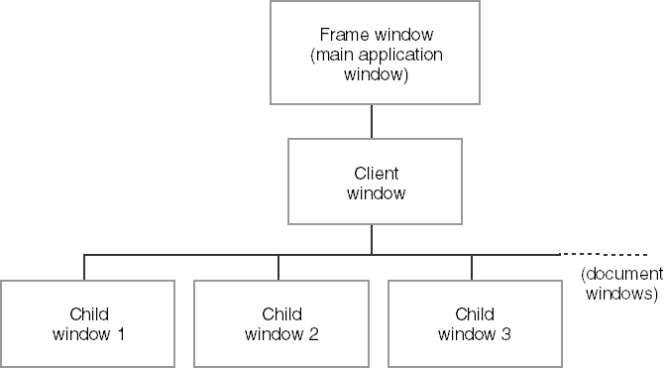

The image depicts the hierarchy of an MDI application. Here's a breakdown of the image and how it relates to the text I previously provided:

* Frame window: This is the main application window, represented at the top of the image as "Frame window (main application window)". It has the familiar elements of a standard Windows window, such as a title bar, menu bar, and sizing border.
* Client window: This window sits beneath the frame window and acts as a container for the child windows. The text describes it as the "client window (MDICLIENT)" and mentions that it covers the client area of the frame window.
* Child windows: These are the individual document windows, shown in the image as "Child window 1", "Child window 2", and "Child window 3". They are all children of the client window and reside within its workspace.

Key Points:

* The client window, while visually subtle, plays a pivotal role in orchestrating MDI functionality.
* Child windows, lacking their own menus, rely on the frame window's menu for user interactions.
* The WM_MDICREATE message is the key to birthing new child windows into the MDI world.

ESSENTIAL ELEMENTS FOR MDI DEVELOPMENT:

Window Classes and Procedures:

Frame Window: Requires its own window class and window procedure to handle events and interactions.

Child Windows: Each type of child window also demands a distinct window class and procedure for unique behaviors.

Client Window: Relies on the pre-registered MDICLIENT class, eliminating the need for a custom window procedure.

MDI Support Components:

Window Class:

* MDICLIENT: The pre-registered class for the client window, responsible for core MDI functionality.

Data Structures:

* CLIENTCREATESTRUCT: Used for client window creation, providing initial configuration.
* MDICREATESTRUCT: Employed for child window creation, defining their properties and behaviors.

Functions:

* DefFrameProc: Replaces DefWindowProc for frame window procedures, handling MDI-specific messages.
* DefMDIChildProc: Substitutes DefWindowProc for child window procedures, managing MDI child window actions.
* TranslateMDISysAccel: Interprets system accelerator keys within the MDI context (similar to TranslateAccelerator).
* CreateMDIWindow: Optional for multi-threaded programs, enabling child window creation in separate threads.

Messages:

* Twelve WM_MDI messages facilitate communication between frame, client, and child windows for tasks like creation, activation, arrangement, and information retrieval.

Key Points:

* Frame Windows Initiate MDI Actions: Frame windows typically initiate MDI operations by sending WM_MDI messages to the client window.
* Client Window Orchestrates Child Windows: The client window handles WM_MDI messages and coordinates actions among child windows.
* WM_MDIACTIVATE Exception: This message is both sent by the frame window to activate a child window and by the client window to inform affected child windows about activation changes.

Building an MDI Application:

1. Register custom window classes for the frame window and any child window types.
2. Create the frame window using CreateWindow.
3. Within the frame window procedure, create the client window using CreateWindow with the MDICLIENT class.
4. Use WM_MDICREATE messages to create child windows as needed.
5. Employ DefFrameProc and DefMDIChildProc for appropriate message handling.
6. Utilize TranslateMDISysAccel for accelerator key translation.
7. Optionally use CreateMDIWindow for child window creation in separate threads.

Remember:

* MDI support simplifies complex MDI application development.
* Understanding these components is crucial for effective MDI implementation.

THE MDIDEMO PROGRAM

Frame Window Procedure (FrameWndProc):

Client Window Creation:

* Employs "MDICLIENT" class for client window, leveraging built-in MDI functionality.
* Utilizes CLIENTCREATESTRUCT to tailor window menu and child window IDs, ensuring a cohesive user experience.

Child Window Handling:

* Manages creation and destruction of child windows via WM_MDICREATE and WM_MDIDESTROY messages, effectively coordinating multiple document interfaces.
* Forwards unhandled commands to active child windows using WM_COMMAND, promoting flexibility and customization within child windows.

Termination Handling:

* Gracefully attempts to close all child windows during session termination or frame window closure, ensuring data integrity and user experience.

Message Routing:

* Employs DefFrameProc for specialized MDI message handling, streamlining MDI-specific behaviors within the frame window.

Client Window Messages:

Child Window Management:

* WM_MDICREATE and WM_MDIDESTROY handle child window lifecycle, ensuring efficient resource allocation and deallocation.
* WM_MDIACTIVATE controls child window focus, enabling seamless user interactions within the MDI environment.
* WM_MDIGETACTIVE retrieves the active child window, facilitating targeted operations and communication.
* WM_MDITILE, WM_MDICASCADE, and WM_MDIICONARRANGE provide visual organization of child windows, enhancing user experience and workspace management.
* Additional messages like WM_MDINEXT, WM_MDIMAXIMIZE, and WM_MDITILE manage child window positions and states, offering a comprehensive toolkit for window manipulation.

Child Window Procedures:

*Window-Specific Data:*

* Utilize WM_CREATE to allocate and store window-specific data using SetWindowLong, enabling tailored functionality and persistence of settings.
* Maintain handles to client and frame windows for efficient communication and coordination within the MDI hierarchy.

*Message Handling:*

* Process child window-specific commands in WM_COMMAND, allowing for unique behaviors and interactions within each child window.
* Perform child window painting in WM_PAINT, ensuring proper visual representation and responsiveness.
* Update menus based on activation status in WM_MDIACTIVATE, maintaining context-specific menu options for user convenience.
* Prompt for confirmation before closing in WM_QUERYENDSESSION and WM_CLOSE, preventing accidental data loss and promoting user control.
* Free resources and data in WM_DESTROY, ensuring proper memory management and preventing leaks.

*Message Routing:*

* Employ DefMDIChildProc for specialized MDI message handling within child windows, ensuring adherence to MDI conventions and behaviors.

Memory Management:

* Efficiently manages memory allocation and deallocation during window creation and destruction using HeapAlloc and HeapFree.
* Ensures proper handling of window-specific data associated with each instance, preventing memory leaks and promoting resource efficiency.

Timer Usage in RectWndProc:

* Utilizes a timer (SetTimer) in the RectWndProc to periodically generate random rectangles.
* Adds a dynamic element to the Rect child window, enhancing visual appeal and user engagement.

Menu Initialization:

* Initializes menus and submenus for various window types during program startup.
* Ensures correct association of menus with the MDI client window, providing a seamless and intuitive user interface.

Window Registration:

* Registers window classes for the frame window, Hello child window, and Rect child window.
* Facilitates proper handling of different window types within the application, contributing to a well-organized and modular structure.

Accelerator Key Translation:

* Incorporates TranslateMDISysAccel to streamline system accelerator key translation within MDI windows.
* Enhances keyboard navigation and user experience by providing consistent and expected behavior for system-defined key combinations.

Structured Window Creation Parameters:

* Utilizes CLIENTCREATESTRUCT and MDICREATESTRUCT to define client window properties and child window creation parameters in a structured manner.
* Promotes code clarity and maintainability by organizing window-related information in a systematic format.

DefFrameProc and DefMDIChildProc:

* Employs DefFrameProc for specialized MDI message handling within the frame window.
* Utilizes DefMDIChildProc for specialized MDI message handling within child windows.
* Ensures adherence to MDI conventions and behaviors, simplifying the implementation of MDI-compliant features.

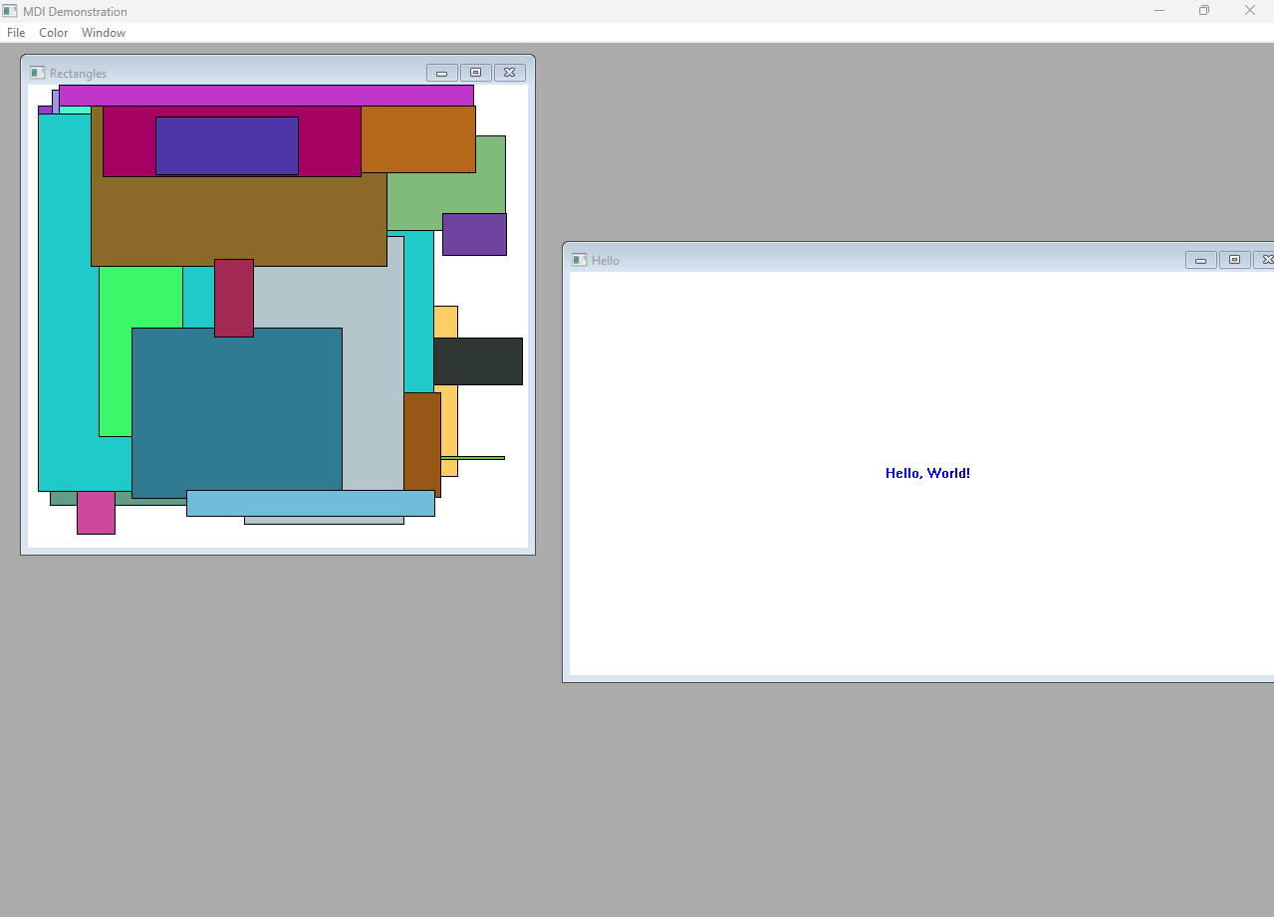

Additional Insights:

* TranslateMDISysAccel: Streamlines system accelerator key translation within MDI windows, enhancing keyboard navigation and user experience.
* CLIENTCREATESTRUCT and MDICREATESTRUCT: Offer structured approaches to defining client window properties and child window creation parameters, promoting clarity and maintainability.
* DefFrameProc and DefMDIChildProc: Expose specialized message handling functions for MDI frame and child windows, simplifying MDI-compliant behavior implementation.

The program in action…



KEY MENU COMPONENTS:

Three Menu Templates:

MdiMenuInit: Initial menu for empty workspace, offering options to create new documents or exit.

MdiMenuHello: Menu for "Hello, World!" document windows, featuring color-changing options and window-arranging controls.

MdiMenuRect: Menu for random rectangle document windows, similar to MdiMenuHello but without color options.

Menu Identifiers:

* RESOURCE.H header file defines all menu IDs.
* INIT_MENU_POS, HELLO_MENU_POS, RECT_MENU_POS: Constants indicating the position of the Window submenu within each menu template, used to inform the client window where to display the document list.
* IDM_FIRSTCHILD: Identifier for the first document window in the Window submenu, ensuring unique IDs for menu items associated with child windows.

Dynamic Menu Behaviors:

Document List in Window Submenu:

* The Window submenu dynamically lists open document windows, providing easy access and management.
* The program correctly positions this list within the appropriate menu template, even for MdiMenuInit (which lacks a visible Window submenu).

Menu Changes Based on Active Window:

* The displayed menu switches based on the active child window, ensuring context-sensitive options and streamlined user experience.

Additional Considerations for MDI Menus:

Message Routing:

The frame window often handles menu-related messages before forwarding unhandled commands to active child windows, enabling centralized control and coordination.

Accelerator Keys:

Consider using TranslateMDISysAccel to enhance keyboard navigation within MDI windows, optimizing user interactions.

Message Handling:

Child window procedures typically handle their specific menu commands within WM_COMMAND message processing, ensuring tailored functionality.

Menu Updates:

Child windows often update menus during WM_MDIACTIVATE to reflect their active/inactive status and provide context-appropriate options, maintaining a consistent user interface.

WINDOW CLASS ORCHESTRATION:

The program carefully creates window classes for different types of windows: the main frame window, the "Hello, World!" document windows, and the random rectangle document windows. Each window class has its own function to handle messages and events.

The background color of the frame window is set to COLOR_APPWORKSPACE to make it visually consistent with the client window.

All three window classes allocate additional space using the cbWndExtra field in the WNDCLASS structure. This extra space is important for storing data specific to each window, allowing for customization and flexibility in the document windows.Menu Management and User Interaction:

The program eagerly loads three distinct menus: MdiMenuInit, MdiMenuHello, and MdiMenuRect. Each menu is designed to cater to specific scenarios within the application's workflow.

The Window submenus, which dynamically list open document windows, are meticulously identified and their handles are stored for efficient access.

An accelerator table is loaded to enhance keyboard navigation and streamline user interactions within the application.

Frame Window Construction:

The WinMain function diligently creates the frame window using the CreateWindow function. This establishes the foundational structure for the MDI application.

During the WM_CREATE message processing, the frame window gracefully orchestrates the creation of the client window. This client window, belonging to the preregistered MDICLIENT class, serves as the cornerstone for MDI functionality.

The client window procedure, acting as a crucial intermediary between the frame window and the document windows, is configured with a CLIENTCREATESTRUCT structure. This structure thoughtfully specifies:

The handle of the Window submenu, initially set to hMenuInitWindow.

The menu ID to be associated with the first document window, designated as IDM_FIRSTCHILD.

Message Loop Mechanics:

The application displays the newly constructed frame window for user interaction.

A tailored message loop, specifically designed for MDI applications, commences to process events:

* Incoming messages are first scrutinized by TranslateMDISysAccel to seamlessly translate MDI-specific accelerator keys, such as Ctrl-F6 for window switching.
* If menu accelerators are present, they are gracefully handled by TranslateAccelerator.
* Should either translation function indicate success, the message is deemed fully processed, and the standard TranslateMessage and DispatchMessage calls are strategically bypassed to ensure efficiency.
* The hwndClient and hwndFrame window handles are thoughtfully passed to the translation functions, empowering them with the necessary context for accurate message interpretation.
* The hwndClient handle, representing the client window, is meticulously obtained using the GetWindow function with the GW_CHILD argument, ensuring a clear reference to the MDI client area.

ORCHESTRATING CHILD WINDOW CREATION:

The frame window:

* The frame window plays a central role in creating child windows.
* It handles WM_COMMAND messages that indicate menu selections for creating new windows.
* It prepares an MDICREATESTRUCT structure with important window information, such as the window title (commonly a filename in real-world applications), desired window styles (like scroll bars or minimized/maximized state), and any optional data to be shared with the child window.
* Finally, it sends a WM_MDICREATE message to the client window, along with the MDICREATESTRUCT, to initiate the creation of the child window.

Responsibilities of the Client Window:

Message Handler:

The client window is responsible for receiving the WM_MDICREATE message and promptly creating the child window based on the provided information.

Updating the Submenu:

It continuously updates the designated submenu with the title of the newly created child window. This ensures a consistent user interface where the submenu reflects the available document windows.

Efficient Document List Management:

The client window effectively manages the document list within the Window submenu. It automatically adds up to nine child window items, each assigned a numbered shortcut for quick navigation.

In cases where more than nine windows are created, the client window carefully includes a "More Windows" item. This item provides access to a comprehensive dialog that lists all active windows, allowing the user to navigate between them conveniently.

Alternative Approaches and Data Exchange:

Direct Creation: While the frame window is typically responsible for creating child windows, developers can also directly create child windows using the CreateMDIWindow function. This provides flexibility in certain scenarios where the frame window's involvement may not be necessary.



Data Sharing: The lParam field of the MDICREATESTRUCT structure serves as a valuable mechanism for sharing data between the frame window and the child window during creation. This allows for efficient communication and coordination between the two, enabling features such as passing filenames or custom settings from the frame window to the child window.



Dynamic Menu Handling:

Automatic Updates: The client window takes care of automatically adding and removing child window items from the Window submenu as windows are created and destroyed. This dynamic behavior ensures that the menu always accurately reflects the current state of the application. It enhances user navigation and window management by providing an up-to-date list of available windows.



Key Takeaways for WinAPI Developers:

MDICREATESTRUCT: Familiarize yourself with this structure to effectively define the properties of child windows during their creation. Understanding its fields and their significance will help you customize and tailor the behavior of child windows according to your application's requirements.

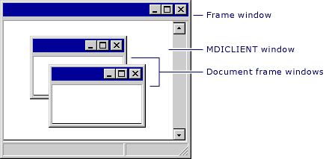

WM_MDICREATE: Comprehend the role of this message in facilitating communication between the frame window and the client window. It serves as a means to request the creation of child windows and allows for the exchange of relevant information.

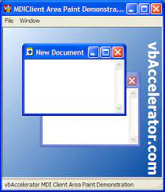

Client Window's Control: Recognize the central role played by the client window in managing the document list and handling menu updates. Understanding this responsibility will enable you to create a seamless user experience with efficient window navigation and management.



Data Sharing: Take advantage of the lParam field in the MDICREATESTRUCT structure to establish efficient communication between the frame window and the child window. Utilizing this field for data exchange can enhance the functionality and customization of your application.



FRAME WINDOW: THE ORCHESTRATOR OF MDI INTERACTIONS

Within an MDI application, the frame window serves as the central hub for managing menu commands and coordinating actions among its child windows. It gracefully handles user interactions with menus and ensures that messages are delivered to the appropriate destinations, fostering a seamless user experience.

Menu Commands: A Variety of Actions

Closing a Child Window: The frame window initiates this process by:



* Retrieving the handle of the active child window using WM_MDIGETACTIVE, ensuring focus on the intended window.
* Respectfully requesting closure confirmation from the child window via WM_QUERYENDSESSION to avoid unexpected data loss.
* If the child window grants permission, the frame window decisively sends WM_MDIDESTROY to the client window, empowering it to undertake the actual destruction of the window.
* Exiting the Application: The frame window initiates termination by sending a WM_CLOSE message to itself. This message triggers a sequence of events that ultimately results in the graceful closure of all windows and the release of application resources.

Arranging Child Windows: The frame window offers users multiple ways to organize the workspace by sending specific messages to the client window:



* WM_MDITILE for a tiled arrangement, neatly stacking windows side by side.
* WM_MDICASCADE for a cascading arrangement, creating an overlapping, waterfall-like effect.
* WM_MDIICONARRANGE for arranging minimized windows within the client area, maintaining visual order.
* Closing All Child Windows: This operation involves a choreographed dance between the frame window and child windows:
* The frame window employs EnumChildWindows to meticulously iterate through each child window, inviting the CloseEnumProc function to the stage for processing.
* CloseEnumProc diligently sends a WM_MDIRESTORE message to each child window, ensuring their visibility and readiness for closure.
* It then respectfully requests closure confirmation via WM_QUERYENDSESSION, respecting each child window's autonomy.
* Upon receiving a positive response, CloseEnumProc decisively sends WM_MDIDESTROY to the client window, triggering the actual destruction of the willing child window.
* The icon title window, however, is gracefully exempt from this process, as indicated by a non-NULL return value from GetWindow with the GW_OWNER argument.

Message Forwarding: Empowering Child Windows

The frame window acknowledges the expertise of child windows in handling certain messages, particularly those pertaining to their unique functionalities.



It gracefully forwards unprocessed WM_COMMAND messages to the active child window, enabling them to respond to user interactions within their specific domains.



This image makes no sense, I just like looking at things while I read.

DefFrameProc: The Unsung Hero of MDI

Default Processing for Frame Windows: This function diligently handles messages that the frame window procedure itself deems unnecessary for custom processing. It ensures that standard MDI behaviors are executed correctly, even when the frame window doesn't explicitly intervene.



Essential for Certain Messages: Specific messages must always be passed to DefFrameProc, even if the frame window traps them for other reasons:

* WM_MENUCHAR: Handles keyboard navigation within menus, maintaining MDI consistency.
* WM_SETFOCUS: Manages focus changes among windows, ensuring proper activation and deactivation.
* WM_SIZE: Orchestrates window resizing behavior, coordinating with the client window to maintain a cohesive layout.
* Unprocessed WM_COMMAND messages: Ensures that MDI-specific commands, such as those generated from the document list in the Window submenu, are handled appropriately.

Document List Management:

* Client Window's Responsibility: The client window, not the frame window, bears the primary responsibility for managing the document list within the Window submenu. This includes:
* Dynamically appending and removing child window items as windows are created and destroyed.
* Handling selections from the document list, activating the corresponding child window.

Window Handle Management:

No Need for Explicit Lists: The frame window elegantly avoids the need to maintain explicit lists of child window handles, streamlining its responsibilities.

EnumChildWindows to the Rescue: Whenever the frame window requires access to child window handles (such as during the Close All operation), it gracefully employs the EnumChildWindows function to effortlessly enumerate them on demand.



Key Takeaways:

* Frame Window as Coordinator: The frame window plays a pivotal role in managing user interactions, coordinating actions among child windows, and forwarding messages to appropriate destinations.
* DefFrameProc as a Reliable Partner: This function ensures that essential MDI behaviors are handled correctly, even when custom message processing is involved.
* Client Window's Role in Document Handling: The client window manages the document list, providing a consistent user experience for navigating between multiple open documents.
* Efficient Window Handle Management: The frame window demonstrates a streamlined approach to window handle management, leveraging EnumChildWindows when needed, promoting a well-organized code structure.

CHILD DOCUMENT WINDOWS

Child Document Windows in an MDI application play an active role in maintaining individuality and participating harmoniously within the MDI framework. Here are some important aspects to consider:

Data Storage for Individuality:

Child document windows need to store unique data that is specific to each window instance. This can be achieved by utilizing window properties or by reserving extra memory space in the cbWndExtra field of the WNDCLASS structure.



The SetWindowLong and GetWindowLong functions can be used to access this extra memory space. For example, the MDIDEMO application stores text color and menu item selection in a HELLODATA structure in the extra window memory.



Menu Management and Activation:

Child windows receive the WM_MDIACTIVATE message when they are activated or deactivated. When a child window is activated, it dynamically switches menus based on the window type (e.g., MdiMenuHello, MdiMenuRect, or MdiMenuInit) using the WM_MDISETMENU message sent to the client window.

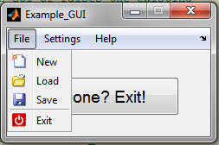

This ensures that the appropriate menu is displayed for each document window, including the document list. The child windows also manage check marks on the Color submenu to reflect the choices made in the active window.

Closure Confirmation and Memory Cleanup:

Child windows handle the WM_QUERYENDSESSION and WM_CLOSE messages to potentially prompt the user for confirmation before closing the window (e.g., to check for unsaved changes).

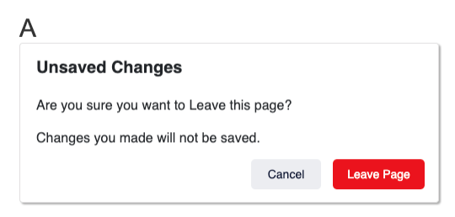

During the WM_DESTROY message, any extra memory allocated for the window should be freed to prevent memory leaks.

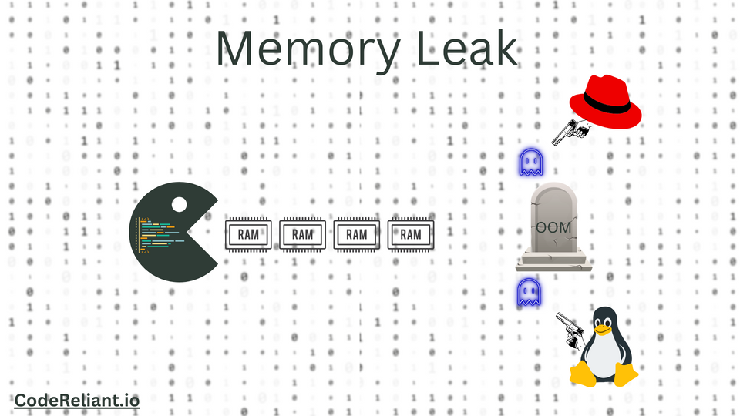

A memory leak is a resource leak that occurs when a computer program incorrectly manages memory allocations.



This can happen when a program allocates memory but doesn't free it, or when an object is stored in memory but can't be accessed by the running code.

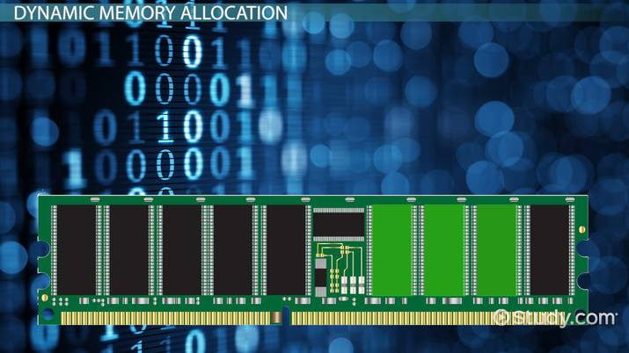

Message Forwarding to DefMDIChildProc:

Any unprocessed messages in the child window should be forwarded to the DefMDIChildProc function for default MDI child window processing.



However, there are specific messages that should always be passed to DefMDIChildProc, regardless of any custom processing implemented: WM_CHILDACTIVATE, WM_GETMINMAXINFO, WM_MENUCHAR, WM_MOVE, WM_SETFOCUS, WM_SIZE, and WM_SYSCOMMAND.



RectWndProc: Simplicity with Shared Fundamentals:

The RectWndProc is a simplified example of an MDI child window procedure that demonstrates common handling mechanisms.



It shares fundamental concepts such as data storage using extra window memory (cbWndExtra), menu management and activation, and message forwarding to DefMDIChildProc.

Key Takeaways for WinAPI Developers:

* Understanding MDI Child Window Responsibilities: Child windows are responsible for menu management, data storage, closure handling, and proper message forwarding.
* Utilizing cbWndExtra for Unique Data: The cbWndExtra field provides a flexible approach for storing window-specific information.
* Collaboration with the Client Window: Child windows work in collaboration with the client window to manage menus and document lists.
* DefMDIChildProc as a Reliable Partner: By forwarding unprocessed messages to DefMDIChildProc, the default MDI child window behaviors are executed correctly.
* RectWndProc as a Streamlined Example: The RectWndProc showcases essential MDI child window concepts without additional complexities, serving as a good starting point for understanding MDI child window implementation.